**This guide basically highlights what I go through to get workflow back up and running when the following is discovered which are the two biggest things workflow is used for.**

1. **Workflow models are not processing it’s activities.**
2. **People who are using TEM are not receiving emails/notifications.**

**The reasoning behind this is usually because the database connection/email daemon is no longer processing items. This can be caused because TEM/Banner database was rebooted without notification or a network change has happened.**

**You can go into the “My Processes” link in the “User Profile” menu then click on “system verification”. This process will allow you to troubleshoot whether the email is functioning in the system and whether the database connection is still active for workflow to query against. If the “system verification” process fails in sending and email or querying the database for data then you’re going to have to restart the workflow server.**

**Workflow server up but can’t reach it via url it means that there is a possibly firewall within the server or externally on the network that is blocking access to the port.**

**Netstat –tulpn | grep 700\***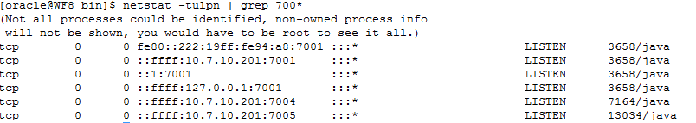

**If you see *.7001 *.7004 *.7005 (* denoting any ip address from 0.0.0.0 to 127.0.0.1) this means that the ports are open and some software is listening in for requests from there.**

**A software (iptables) or even external hardware firewall can possibly be enabled or a physical firewall is preventing traffic from reaching the server. You’ll need sudo/root access to run the following commands.**

**You can check if iptables is enabled by running the following to see if it is on:  
chkconfig | grep iptables  
chkconfig** [**http://linuxcommand.org/man_pages/chkconfig8.html**](http://linuxcommand.org/man_pages/chkconfig8.html) **– updates and queries runlevel information for system services. It’s equivalent to running msconfig in windows to enable or disable a service.**

**disable iptables by running:**

***Service iptables off***

**=====================================================================================**

**Using engine.log to check for any errors/connection errors.**

You can view any disconnects from the workflow engine to the banner database by viewing the engine.log file located in the following path:  
/home/u01/workflow81/live/engine/ engine.log  
/home/u01/workflow81/dev8/engine/engine.log

Basically check for anything concerning a disconnect from the JDBC/connection pool/timeouts etc.  
If there is a disconnect from the database, you’re more likely going to have to restart the weblogic server for workflow so that it can re-establish a connection.

**Stopping and starting workflow engine in case any errors/connections go down.**

How to restart workflow in case nothing is happening, meaning the workflow models activities are stuck on a running man.

Log into <http://wf8.westernu.edu:7004/wflive/> (as admin of course)  
Go to Workflow System Administration link -> Engine manager -> Click STOP.  
The following should now be pictured:

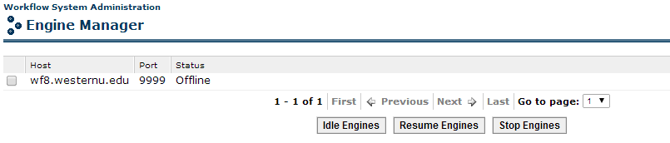

Now log into wf8.westernu.edu via ssh and go into the following path and run the startengine file to start the engine again:

/home/u01/workflow81/live/engine/bin/startengine  
/home/u01/workflow81/dev8/engine/bin/startengine  
The following should show:



Now go back to <http://wf8.westernu.edu:7004/wflive/> as admin and check the Engine Manager to make sure the engine status is online.  
It should look like this:  
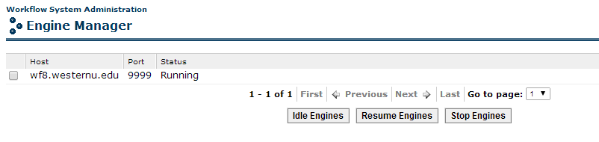

If nothing is happening with the workflow engine, meaning no activities are processing then you will have to stop the engine, then log into weblogic and restart the application the workflow resides in.

**How to restart weblogic application server for workflow  
You’re going to have to do this most likely if the workflow server is down (unreachable) or the database connection was disconnected.**

Weblogic url (houses applications for both dev/live):

<http://wf8.westernu.edu:7001/console> as the *weblogic* user

1. Expand the Environment under base_domain and click servers  
   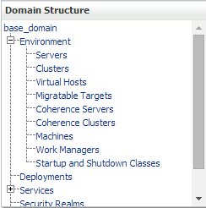
2. Click the Control tab within the “Summary of Servers” page to get to the area where you can start/resume/suspend/shutdown/restart SSL the application server.  
   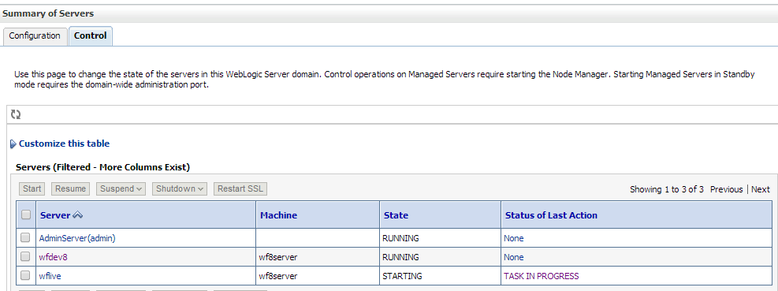
3. Click the checkbox for the server you want to shutdown (Example check wflive) then click the shutdown drop down menu and select **FORCE SHUT DOWN, if you select WHEN WORK COMPLETES, the server will not shut down since workflows activities are not working so in essence work will never be complete for it to shut down. After 60 seconds you should be successful in shutting down the server.**

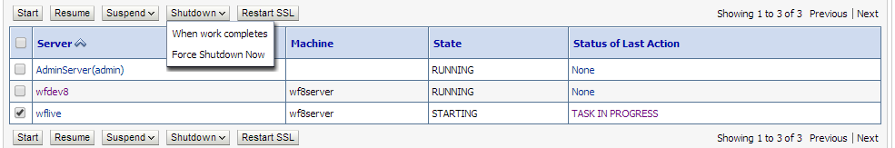

1. To start the server, simply click the checkbox for wflive and click start. Within 60 seconds the State of the application should reflect “RUNNING”.

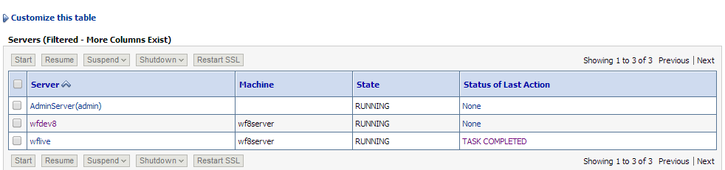

Now workflow should be back up and running but you’ll still need to start the engine up in order for workflow models/activities to be processed.

If you try to start the server up and you are unable to do so, you can check the AdminServer logs for weblogic via linux shell and see what may be preventing it from starting up.

**Known causes for not starting up**

1. **Memory allocation. For some reason sometimes it’ll complain that there is not enough memory to load in the server. You’re going to have to increase the size of this.**
2. **Java isn’t running or there is a memory leak somewhere preventing java from running correctly. Either try killing the java processes or if all else fails… and if only you can try rebooting the system.**